JOB PORTAL SYSTEM

Table of Contents

Introduction 2
Purpose 2
Scope 2
Objectives 3
Functional Requirements 3
Primary actors of the system 3
Use Case Diagram 3
User Stories 3
Business Process Diagram 4
Non-Functional Requirements 4
Technical Requirements 4
Conclusion

1.INTRODUCTION
The job portal system serves as an online platform linking job seekers with employers. It streamlines job matching, applications, and recruitment processes efficiently. Defining system requirements clearly is vital for smooth project development. It helps prevent misunderstandings during the development stages. Clear requirements also support successful implementation and easy maintenance.
1.1 Purpose
The purpose of the Job Portal System is to connect job seekers and employers on one platform. It helps job seekers find suitable jobs and employers find qualified candidates easily. The system simplifies recruitment, saves time, improves communication, and makes the hiring process faster and more efficient for both parties.
1.2 Scope
The job portal system connects job seekers and employers online. It allows job seekers to create profiles, upload resumes, and apply for jobs, while employers can post vacancies and search for candidates. The admin manages users and system operations. The system focuses on online recruitment and job search to make the hiring process faster and easier.
1.3 Objective
- The high-level objective is to create an intuitive, user-friendly platform that streamlines job matching and application processes.

- The system aims to address challenges such as lack of centralized recruitment platforms, inefficient job searches, and difficulties faced by employers in finding qualified candidates
2.Functional Requirements
2.1 Primary Actors
  - Job Seeker
  - Job Provider
  - Platform Admin
2.1 Job Seeker
Registers on the portal and creates a profile by uploading resume, entering personal, educational, and skills information Searches and applies for jobs using filters based on location, experience, industry, etc. Receives job alerts and notifications for relevant openings Manages their profile, updating experience and skills, and tracks application status Maintains privacy of personal data until it is shared with potential employers.
2.2 Job Provider
Registers itself (company) on the portal and adds a company profile Posts job v vacancies, specifying required skills, experience, and other job details Searches candidate resumes in the portal’s database using advanced filters. Reviews applications received from job seekers and offers jobs to suitable candidates Uses the platform to build an employer brand and reach wider talent pools.
2.3 Platform Admin
Manages all aspects of the system and database, including job seekers, job providers, and posted jobs Updates, deletes, or modifies information for any user or listing when necessary Monitors postings and user activity to ensure compliance and correct operation Sends notifications or messages (such as updates and job offers) to users Generates and manages reports about users, jobs, and platform activities.
2.2 Use Case Diagrams

Job Seeker Use Case Diagram

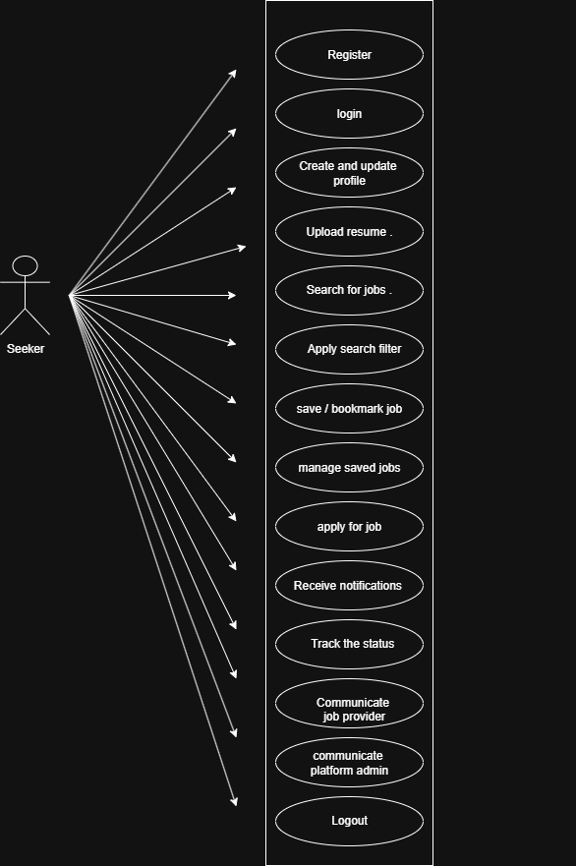
Job Provider Use Case Diagram

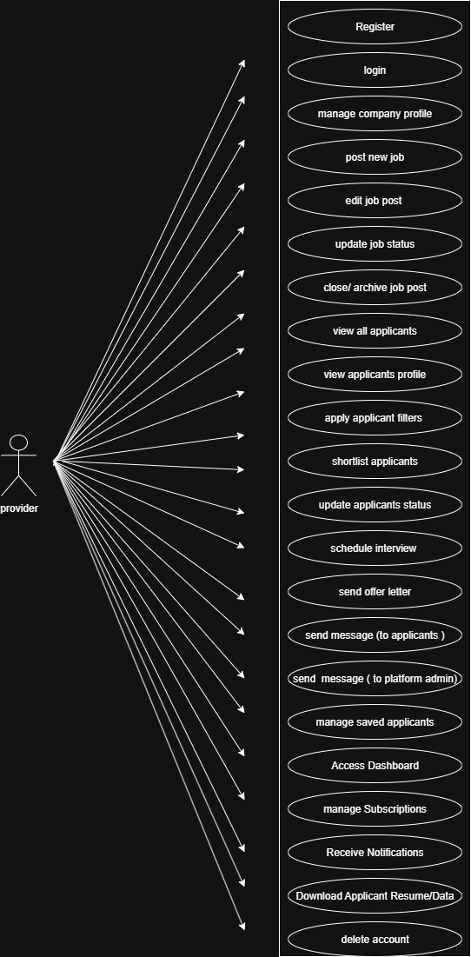
Platform Admin Use Case Diagram

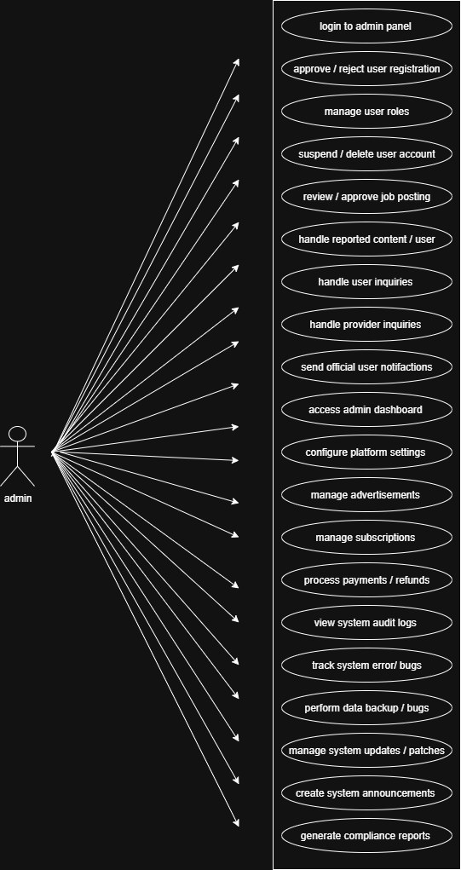
2.3 User Stories
As a [ type of user] | I Need To [ do some task ] | So that I can [ get some result ]
Job Seeker | Register into the application by entering my personal details. | Create my account and access features available for registered users.
Job Seeker | Login to the system using my credentials. | Securely access my dashboard and profile.
Job Seeker | Create and update my professional profile including skills, education, and experience. | Showcase my qualifications to potential employers.
Job Seeker | Upload or update my resume on the portal. | Allow job providers to view and download my latest resume.
Job Seeker | Search for jobs using filters like job title, company, or location. | Find suitable job opportunities that match my interests.
Job Seeker | I need to save or bookmark job postings that interest me, | so that I can easily access them later for review or application.
Job Seeker | I need to manage and view all my saved or bookmarked jobs, | so that I can keep track of my preferred opportunities conveniently.
Job Seeker | Apply for a job from the job portal. | Be considered for positions and potentially get hired.
Job Seeker | Receive notifications or alerts for new job postings. | Stay informed about relevant opportunities.
Job Seeker | Track the status of my applied jobs. | Know whether my application is viewed, shortlisted, or rejected.
Job Seeker | Communicate with job providers through messages or chat. | Clarify job details and coordinate interviews.
Job Seeker | Logout from the system. | Ensure my account security after using the platform.

Job Provide User Storie
As a [user type] | I Need To [do some task] | So That I can[get some results]
Job Provider | Register into the application by entering my details | Create an account, build trust with job seekers, and access features reserved for verified employers.
Job Provider | log in to the application using my registered email and password | access my dashboard and manage my job postings securely
Job Provider | Profile creation by entering company details | Profile for the job seeker to know about the company
Job Provider | Post a new job opening with role details, qualifications, and location | Advertise opportunities and attract suitable candidates.
Job Provider | Edit, update, or close a job posting | Keep job listings accurate and remove filled positions.
Job Provider | Keep job listings accurate and remove filled positions. | Track and manage all candidates in one place.
Job Provider | Review candidate profiles and resumes | Assess applicants’ skills and experience for the role
Job Provider | Accept, Reject, or Shortlist candidates | Move candidates forward in the hiring process.
Job Provider | interview invites to applicants | schedule interviews efficiently.
Job provider | Send messages | Communicate with applicants
Job Provider | Filter applicants by qualifications, skills, or location | Quickly identify the most relevant candidates.
Job Provider | Save or bookmark promising candidates | Revisit their profiles later for current or future openings.
Job Provider | Access a dashboard with job performance stats (views, applications, hires) | Monitor effectiveness of postings and optimize hiring strategy.
Job Provider | Purchase or upgrade a subscription plan | Unlock premium features like promoted listings or unlimited postings.
Job Provider | Receive notifications of new applications | Respond to candidates promptly and not miss opportunities.
Job Provider | Download applicant resumes and reports | Maintain records for internal HR processes
Job Provider | Deactivate or delete my account if needed | Exit the platform while ensuring data is securely removed

Platform Admin User Storie
As a [ user type] | I Need To [d0 some task] | So That I Can [get some results]
Platform Admin | Approve or verify new job provider and job seeker accounts | Ensure only legitimate users have access to the platform
Platform Admin | Manage user roles and permissions | Control access to features and maintain platform security
Platform Admin | Monitor and moderate job postings | Prevent fake or inappropriate job listings
Platform Admin | View and manage all registered users | Keep track of platform activity and maintain order
Platform Admin | Suspend or delete users violating policies | Protect platform integrity and ensure compliance with rules
Platform Admin | Access system dashboard with analytics and reports | Analyz user activity, growth, and performance metrics
Platform Admin | Configure platform settings (categories, industries, locations) | Keep the platform organized and user-friendly
Platform Admin | Manage advertisements or promotional banners | Generate revenue and maintain visual appeal
Platform Admin | Handle reported issues or user complaints | Resolve conflicts quickly and maintain user trust
Platform Admin | Oversee payment and subscription transactions | Ensure financial operations run smoothly and transparently
Platform Admin | Backup and maintain platform database | Prevent data loss and ensure platform reliability
Platform Admin | Update or maintain system content (FAQs, policies, etc.) | Keep users informed and compliant with latest guidelines
Platform Admin | Track technical errors or bugs | Work with developers to maintain smooth platform performance
Platform Admin | Send global notifications or announcements | Communicate updates or alerts to all users efficiently
Platform Admin | Generate detailed usage and compliance reports | Support management decisions and ensure accountability

  - Business Process Diagram
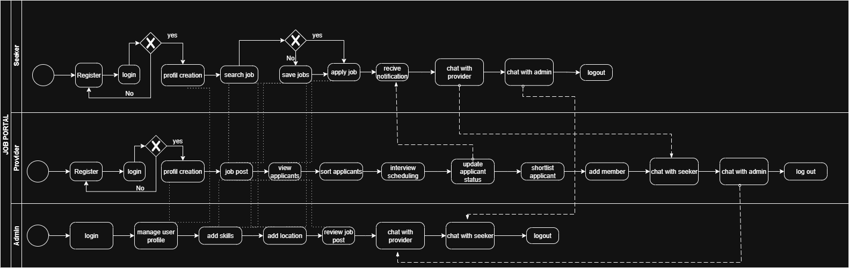

3 Non-Functional Requirements
Non-functional requirements define the system’s quality attributes, constraints, and operational characteristics. They ensure that the system performs efficiently, securely, and reliably under all conditions.

3.1 Performance Requirements
- The system should support at least 1,000 concurrent users without performance degradation.
- Average page load time should not exceed 3 seconds under normal network conditions.
- Search and filtering operations should return results within 2 seconds for queries up to 10,000 records.
- The system must be capable of handling simultaneous job postings and applications efficiently.
3.2 Reliability and Availability
- The system should maintain an uptime of 99.5% (excluding scheduled maintenance).
- Automatic data backup should occur daily to prevent data loss.
- In the event of a failure, the system should recover within 5 minutes using backup and recovery mechanisms
3.3 Security Requirements
- All sensitive data (passwords, resumes, personal info) must be encrypted using AES-256 or equivalent.
- The system must use HTTPS for all data transmission.
- User authentication should be managed through secure login (email/password) with session timeouts.
- Role-based access control (RBAC) must restrict actions based on user type (Admin, Employer, Job Seeker).
- The system should comply with data privacy laws such as GDPR for handling user data.
3.4 Usability Requirements
- The interface should be intuitive and user-friendly, allowing users to complete major actions (e.g., applying for a job, posting a job) within 3 clicks.
- The design should follow responsive web design principles, ensuring usability across desktops, tablets, and smartphones.
- Provide tooltips, help sections, and FAQs for user assistance.
- Ensure accessibility compliance (WCAG 2.1) for users with disabilities.
3.5 Maintainability Requirements
- The system should be modular, allowing updates or bug fixes without affecting unrelated modules.
- Documentation must be maintained for code, APIs, and database structures.
- System updates should be deployable with minimal downtime (<10 minutes).
3.6 Scalability Requirements
- The system should allow easy horizontal scaling (adding more servers) to accommodate increased users or job postings.
- Database design should support growth up to 1 million records without performance issues.
3.7 Portability Requirements
- The system should be compatible with major web browsers (Chrome, Edge, Firefox, Safari).
- It should be deployable on Windows, Linux, or cloud environments such as AWS or Azure.
3.8 Backup and Recovery
- Full system backups should be performed daily and stored securely off-site.
- Incremental backups should occur every 6 hours.
- Backup data must be encrypted and verified for integrity.
3.9 Legal and Ethical Requirements
- The system must comply with data protection regulations (GDPR, CCPA).
- All user data must be used only for recruitment-related purposes and not shared without consent.
- Employers must agree to terms of service and privacy policy before posting jobs.

4. Technical Requirements
Software Requirements
Operating system
- Windows Server ,Linux(Ubuntu/Cent OS),or cloud Based platform like AWS or Azure
Frontend Technologies:
- HTML5,CSS3,Bootstrap , JavaScript
- Frameworks : Angular
Backend Technologies:
- Programing Languages:C#Asp.Net
- Database : Microsoft SQL Server
5 Conclusion
The Job Portal System is designed to provide an efficient, secure, and user-friendly platform that bridges the gap between job seekers and employers. By combining robust functionality with strong non-functional qualities such as performance, reliability, and security, the system ensures a smooth and trustworthy experience for all users.
Through responsive design, data protection measures, and scalable architecture, the platform supports long-term growth and adaptability to future needs. Overall, this system aims to streamline the recruitment process, enhance accessibility, and contribute to a more organized and transparent job market.

